ChemOffice Enterprise Search Service

Revision History
Date | Revision | Description | Contributors
10/10/06 | v.1 | Initial draft | Leandro Lillo, Facundo Galdeano, Cecilia Amadio

Copyright © 2006 CambridgeSoft Corporation. Cambridge, Massachusetts.
All Rights Reserved

This document is the property of CambridgeSoft Corporation and is intended for internal use only. Reproduction or transmission of this document in any form, in whole or in part, without prior written permission of CambridgeSoft Corporation is prohibited.

MolServer Integration

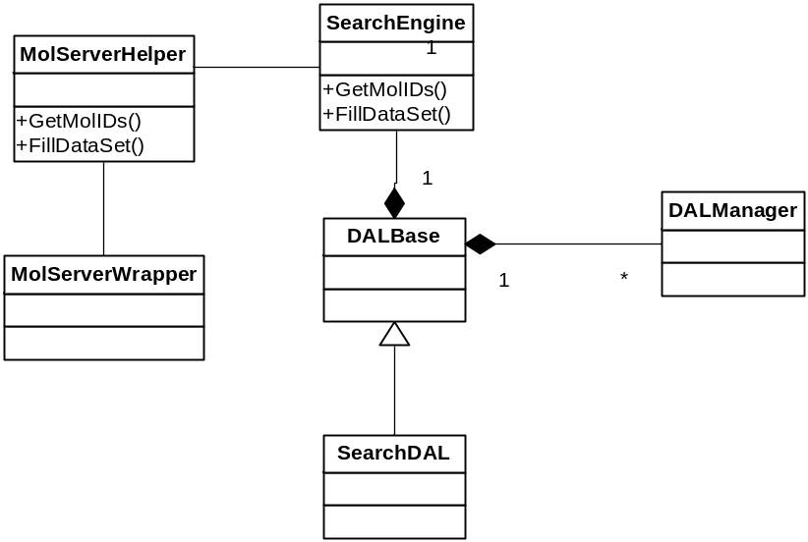

In order to integrate MolserverWrapper to the existing DAL layer, we think that an alternative would be as following:
DALBase will include the SearchEngine as a property, analog to the Database property. Currently this search engine would only make sense for MolServer, but other implementation may be necessary in the future.
This searchEngine exposes two main methods:

- IList GetMolIds(SearchInfo Criterium).
This method will return a list of molecules Ids that match the single search criterium.

- FillDataSet(ref DataSet partiallyFilledDataSet, string tableName, string molIDColumnName, [string newColumnName], SearchInfo criterium)
This method will fill the data table tableName of the dataset partiallyFilledDataSet, creating a new column called newColumnName and will fill it with the matches of the searchInfo criterium.

Will the functionality provided by MolServerWrapper be accessed from other layers than the searchService? If this is not the case, the SearchEngine property could be in the SearchDAL rather than in the DALBase.

Does this schema make sense to you? We would like to know your opinion.

